Natural Wellbeing Tips

Having difficulties with your emotional wellbeing can make you feel helpless, but you're not! There's a lot you can do on your own to fight back. Changing your behavior -- your physical activity, lifestyle, and even your way of thinking -- are all natural ways you can improve your mental health.

These tips can help you feel better -- starting right now.
- Get in a routine:

If you’re feeling low, a routine can help and setting a gentle daily schedule can help you get back on track. Consider using a timetabling app, such as Class Timetable, to help you get back on track.

- Set goals:

When you’re down, it can sometimes feel like you can't accomplish anything. To push back, set daily goals for yourself.

Start very small, make your goal something that you can succeed at and as you start to feel better, you can add more challenging daily goals.

- Exercise:

Exercise has positive benefits on for peoples’ mental health in the short-term and long term.
It temporarily boosts feel-good chemicals called endorphins and seems to encourage the brain to rewire itself in positive ways.

How much exercise do you need? You don’t need to run marathons to get a benefit. Just walking or running a few times a week can help.

- Eat healthily:

There is no magic diet that fixes low mood. It's a good idea to watch what you eat, though, as our moods can impact our eating habits and getting in control will help you to feel better.

Although nothing is definitive, there's evidence that foods with omega-3 fatty acids (such as salmon and tuna) and folic acid (such as spinach and avocado) could help improve low moods.

- Get enough sleep:

Difficulties with your mood can make it hard to get enough shut-eye, but there are things you can do to make it easier.

- Try going to bed and getting up at the same time every day, ensuring not to nap if possible.
- Consider removing distractions from your bedroom such as phones, tablets, and games consoles.
- Try mindfulness meditation, it can be very calming before going to sleep.

- Take on small responsibilities:

When you’re feeling it can sometimes feel very difficult to keep up with responsibilities.

Having daily responsibilities, however, can help you maintain a lifestyle that can help improve your wellbeing. Small steps will help you climb high and even minor responsibilities can help to give you a sense of accomplishment.

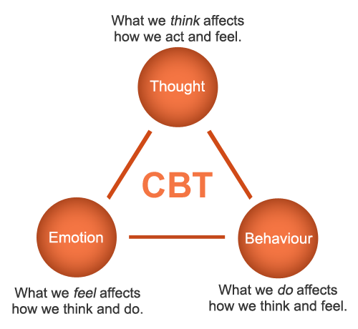
- Challenge negative thoughts:

In your fight against low mood, a lot of the work is about changing how you think.

The next time you're feeling low, use logic as a natural treatment. Is there any real evidence for your negative thoughts? It takes practice, but in time you can beat back those negative thoughts before they get out of control.

- Do something new:

When we challenge ourselves to do something different, there are chemical changes in the brain. Trying something new alters the levels of dopamine, a chemical in the brain which is associated with pleasure, enjoyment, and learning.

Push yourself to do something different. Go to a museum. Pick up a used book and read it on a park bench. Volunteer at a charity. Take a language class.

- Try to have fun:
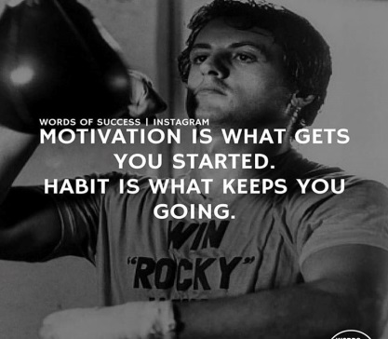
Try to make time for things you enjoy. As strange as it might sound, sometimes you need to work at having fun. Plan things you used to enjoy, even if they feel like a chore. Keep going to the movies. Keep going out with friends for dinner.

When you're sad, you can lose the knack for enjoying life. Make time for enjoyment and, in time, things really will feel fun again.

